DSA0502 – Query Processing for Data Science
Course Faculty | Dr. B .SHYAMALA GOWRI
Reg. No. | 192424030
Student Name | DINESH K
Date | 23/07/2026

LAB PROGRAMS 1 AND 2

Program 7
Question: Create a Pivot table and find the maximum and minimum sale value of the items.
Aim: To implement the given Pandas program successfully.
Dataset :
%%writefile sales.csv
Item,Region,Manager,Salesman,Units_Sold,Sale_Value
Laptop,North,Raj,Amit,10,500000
Laptop,South,Priya,Ravi,12,600000
Laptop,East,Raj,Sneha,8,400000
Laptop,West,John,Kiran,15,750000
Mouse,North,Priya,Amit,20,20000
Mouse,South,John,Ravi,25,25000
Mouse,East,Raj,Sneha,18,18000
Mouse,West,Priya,Kiran,22,22000
Keyboard,North,Raj,Amit,15,45000
Keyboard,South,John,Ravi,20,60000
Keyboard,East,Priya,Sneha,16,48000
Keyboard,West,Raj,Kiran,14,42000
Monitor,North,John,Amit,5,75000
Monitor,South,Priya,Ravi,6,90000
Monitor,East,Raj,Sneha,4,60000
Monitor,West,John,Kiran,7,105000

Code
import pandas as pd
df=pd.read_csv('sales.csv')
print(pd.pivot_table(df,index='Item',values='Sale_Value',aggfunc=['max','min']))
Output
Maximum and minimum sale value of each item.

Result
Thus, the program was executed successfully and the expected output was obtained.
Program 8
Question: Create a Pivot table and find the item wise unit sold.
Aim: To implement the given Pandas program successfully.
Dataset :
%%writefile sales.csv
Item,Region,Manager,Salesman,Units_Sold,Sale_Value
Laptop,North,Raj,Amit,10,500000
Laptop,South,Priya,Ravi,12,600000
Laptop,East,Raj,Sneha,8,400000
Laptop,West,John,Kiran,15,750000
Mouse,North,Priya,Amit,20,20000
Mouse,South,John,Ravi,25,25000
Mouse,East,Raj,Sneha,18,18000
Mouse,West,Priya,Kiran,22,22000
Keyboard,North,Raj,Amit,15,45000
Keyboard,South,John,Ravi,20,60000
Keyboard,East,Priya,Sneha,16,48000
Keyboard,West,Raj,Kiran,14,42000
Monitor,North,John,Amit,5,75000
Monitor,South,Priya,Ravi,6,90000
Monitor,East,Raj,Sneha,4,60000
Monitor,West,John,Kiran,7,105000
Code
import pandas as pd
df=pd.read_csv('sales.csv')
print(pd.pivot_table(df,index='Item',values='Units_Sold',aggfunc='sum'))
Output
Item-wise units sold.
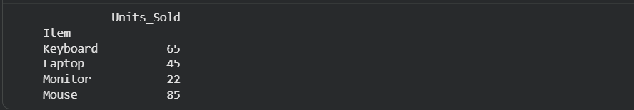
Result
Thus, the program was executed successfully and the expected output was obtained.

